JK Lakshmipat University

Institute of Engineering & Technology



Assignment Set 1

Submitted By:
Siddhi Nyati (2022btech101)

Faculty
Dr. Pranab Roy

Dec 2025

Question 1
Problem Statement
Given an array of size n, insert integer data in the following four different input orders:
a) Random data
b) Data inserted in descending order
c) Half of the data in random order and the remaining half in descending order
d) Data inserted in ascending order
For each case, perform Insertion Sort (ascending order) and compute:
- Total number of comparisons (including loop conditions)
- Total number of assignments (=) used for data movement or swaps
Assume:
- Each comparison takes 1 unit time
- Each assignment takes 1 unit time
Add these timings to obtain the overall time complexity for each case and compare the results.
C++ Code
#include <iostream>
#include <vector>
#include <cstdlib>
#include <ctime>
using namespace std;
struct Cost {
long long comparisons = 0;
long long assignments = 0;
};
void insertionSort(vector<int>& arr, Cost &cost) {
int n = arr.size();

for (int i = 1; i < n; i++) {
cost.comparisons++;
int key = arr[i];
cost.assignments++;

int j = i - 1;

while (j >= 0) {
cost.comparisons++;
cost.comparisons++;

if (arr[j] > key) {
arr[j + 1] = arr[j];
cost.assignments++;
j--;
} else {
break;
}
}
arr[j + 1] = key;
cost.assignments++;
}
}
vector<int> generateAscending(int n) {
vector<int> a(n);
for (int i = 0; i < n; i++) a[i] = i + 1;
return a;
}
vector<int> generateDescending(int n) {
vector<int> a(n);
for (int i = 0; i < n; i++) a[i] = n - i;
return a;
}
vector<int> generateRandom(int n) {
vector<int> a(n);
for (int i = 0; i < n; i++) a[i] = rand() % 1000;
return a;
}
vector<int> generateHalfRandomHalfDescending(int n) {
vector<int> a;
int half = n / 2;

for (int i = 0; i < half; i++)
a.push_back(rand() % 1000);

for (int i = half; i < n; i++)
a.push_back(n - i);

return a;
}
void testCase(const string& title, vector<int> arr) {
Cost cost;
insertionSort(arr, cost);

cout << "\n" << title << endl;
cout << "Comparisons : " << cost.comparisons << endl;
cout << "Assignments : " << cost.assignments << endl;
cout << "Total Cost : " << cost.comparisons + cost.assignments << endl;
}
int main() {
srand(time(0));
int n;

cout << "Enter array size: ";
cin >> n;

testCase("Case A: Random Data", generateRandom(n));
testCase("Case B: Descending Order", generateDescending(n));
testCase("Case C: Half Random Half Descending", generateHalfRandomHalfDescending(n));
testCase("Case D: Ascending Order", generateAscending(n));

return 0;
}
Output
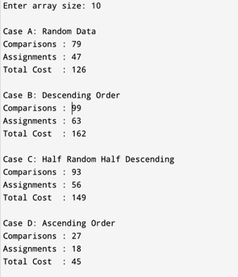
Question 2
Problem Statement
A dynamic array is initialized with size 1.
Whenever the array becomes full, its size is doubled.
The cost model is defined as follows:
- Inserting one element into the array costs 1 unit
- When resizing occurs, copying each existing element costs 1 unit per element
Using the Banker’s Method of Amortized Analysis, perform insertion of n elements into the dynamic array and compute:
- Actual cost of each insertion
- Amortized cost for inserting n elements
Finally, show that the amortized cost per insertion is O(1).
C++ Code
#include <iostream>
using namespace std;
int main() {
int n;
cout << "Enter number of elements to insert: ";
cin >> n;

int capacity = 1;
int size = 0;
int bankBalance = 0;

int totalActualCost = 0;
int totalAmortizedCost = 0;

int* arr = new int[capacity];

cout << "\nStep | Size | Capacity | Actual Cost | Bank Balance\n";
cout << "---------------------------------------------------\n";

for (int i = 1; i <= n; i++) {

int actualCost = 1;
int amortizedCharge = 3;
bankBalance += (amortizedCharge - actualCost);
if (size == capacity) {
int copyCost = size;
actualCost += copyCost;
bankBalance -= copyCost;

capacity *= 2;
int* newArr = new int[capacity];

for (int j = 0; j < size; j++)
newArr[j] = arr[j];

delete[] arr;
arr = newArr;
}
arr[size++] = i;

totalActualCost += actualCost;
totalAmortizedCost += amortizedCharge;

cout << i << " | " << size
<< " | " << capacity
<< " | " << actualCost
<< " | " << bankBalance << endl;
}

cout << "\nTotal Actual Cost : " << totalActualCost;
cout << "\nTotal Amortized Cost : " << totalAmortizedCost;
cout << "\nAmortized Cost per Insertion = "
<< (double)totalAmortizedCost / n << endl;

delete[] arr;
return 0;
}
Output
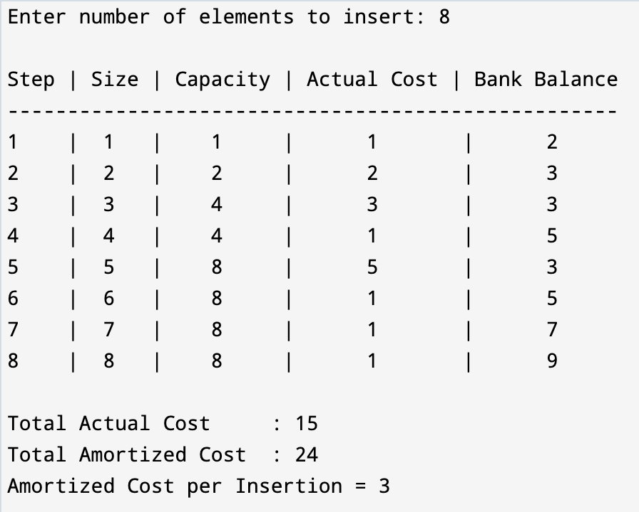
Question 3
Problem Statement
Write a program to simulate a binary counter of n bits.
The implementation cost is defined as follows:
- Every time a bit flips from 0 → 1, pay:
  - Actual cost = $1
  - Additionally, put $1 into a piggy bank
  - Total cost spent = $2
- Every time a bit flips from 1 → 0, pay the cost of $1 using the money stored in the piggy bank.
The program should:
- Display the binary counter value at each step
- Display the actual cost, amortized cost, and piggy bank balance
- Finally compute the amortized cost after the nth operation
C++ Code
#include <iostream>
#include <vector>
using namespace std;

int main() {
int n;
cout << "Enter number of bits: ";
cin >> n;

vector<int> counter(n, 0);
int piggyBank = 0;
int totalActualCost = 0;
int totalAmortizedCost = 0;

int operations = 1 << n; // 2^n operations

cout << "\nStep | Binary Counter | Actual Cost | Amortized Cost | Piggy Bank\n";
cout << "------------------------------------------------------------------\n";

for (int step = 1; step <= operations; step++) {

int actualCost = 0;
int amortizedCost = 0;

// Increment binary counter
for (int i = n - 1; i >= 0; i--) {
if (counter[i] == 0) {
counter[i] = 1;
actualCost += 1;
amortizedCost += 2;
piggyBank += 1;
break;
} else {
counter[i] = 0;
actualCost += 1;
piggyBank -= 1;
}
}

totalActualCost += actualCost;
totalAmortizedCost += amortizedCost;

cout << step << " | ";
for (int bit : counter) cout << bit;
cout << " | " << actualCost
<< " | " << amortizedCost
<< " | " << piggyBank << endl;
}

cout << "\nTotal Actual Cost : " << totalActualCost << endl;
cout << "Total Amortized Cost : " << totalAmortizedCost << endl;
cout << "Amortized Cost per Operation = "
<< (double)totalAmortizedCost / operations << endl;

return 0;
}
Output
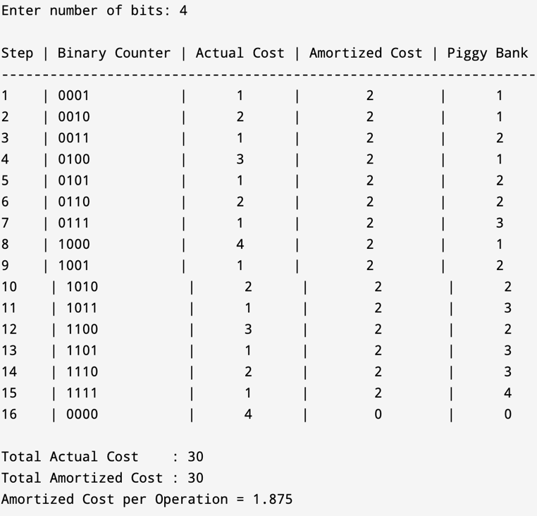
Question 4
Problem Statement
Given a directed graph with weighted edges, find:
- The maximum flow from a given source node to a sink node
- A corresponding minimum cut
The graph must be represented using an adjacency matrix.
The program should:
- Display each augmenting path found
- Display the flow added in each step
- Display the current maximum flow after every step
- Display the final maximum flow
- Display the edges that form the minimum cut
The Ford–Fulkerson method should be used to compute the maximum flow.
C++ Code
#include <iostream>
#include <vector>
#include <queue>
#include <climits>
using namespace std;

bool bfs(vector<vector<int>>& rGraph, int s, int t,
vector<int>& parent, int V) {

vector<bool> visited(V, false);
queue<int> q;

q.push(s);
visited[s] = true;
parent[s] = -1;

while (!q.empty()) {
int u = q.front();
q.pop();

for (int v = 0; v < V; v++) {
if (!visited[v] && rGraph[u][v] > 0) {
parent[v] = u;
visited[v] = true;
q.push(v);
if (v == t)
return true;
}
}
}
return false;
}

void dfsMinCut(vector<vector<int>>& rGraph, int s,
vector<bool>& visited, int V) {
visited[s] = true;
for (int v = 0; v < V; v++) {
if (rGraph[s][v] > 0 && !visited[v])
dfsMinCut(rGraph, v, visited, V);
}
}

int main() {
int V;
cout << "Enter number of vertices: ";
cin >> V;

vector<vector<int>> graph(V, vector<int>(V));

cout << "Enter adjacency matrix (capacities):\n";
for (int i = 0; i < V; i++)
for (int j = 0; j < V; j++)
cin >> graph[i][j];

int source, sink;
cout << "Enter source vertex: ";
cin >> source;
cout << "Enter sink vertex: ";
cin >> sink;

vector<vector<int>> rGraph = graph;
vector<int> parent(V);
int maxFlow = 0;
int step = 1;

cout << "\nAugmenting Paths and Flow Updates:\n";

while (bfs(rGraph, source, sink, parent, V)) {

int pathFlow = INT_MAX;
for (int v = sink; v != source; v = parent[v]) {
int u = parent[v];
pathFlow = min(pathFlow, rGraph[u][v]);
}

cout << "Step " << step++ << " Path: ";
for (int v = sink; v != -1; v = parent[v])
cout << v << " ";
cout << "| Flow Added = " << pathFlow << endl;

for (int v = sink; v != source; v = parent[v]) {
int u = parent[v];
rGraph[u][v] -= pathFlow;
rGraph[v][u] += pathFlow;
}

maxFlow += pathFlow;
cout << "Current Max Flow = " << maxFlow << "\n\n";
}

cout << "Final Maximum Flow = " << maxFlow << endl;

vector<bool> visited(V, false);
dfsMinCut(rGraph, source, visited, V);

cout << "\nMinimum Cut Edges:\n";
for (int i = 0; i < V; i++) {
for (int j = 0; j < V; j++) {
if (visited[i] && !visited[j] && graph[i][j] > 0)
cout << i << " -> " << j << endl;
}
}

return 0;
}
Output
